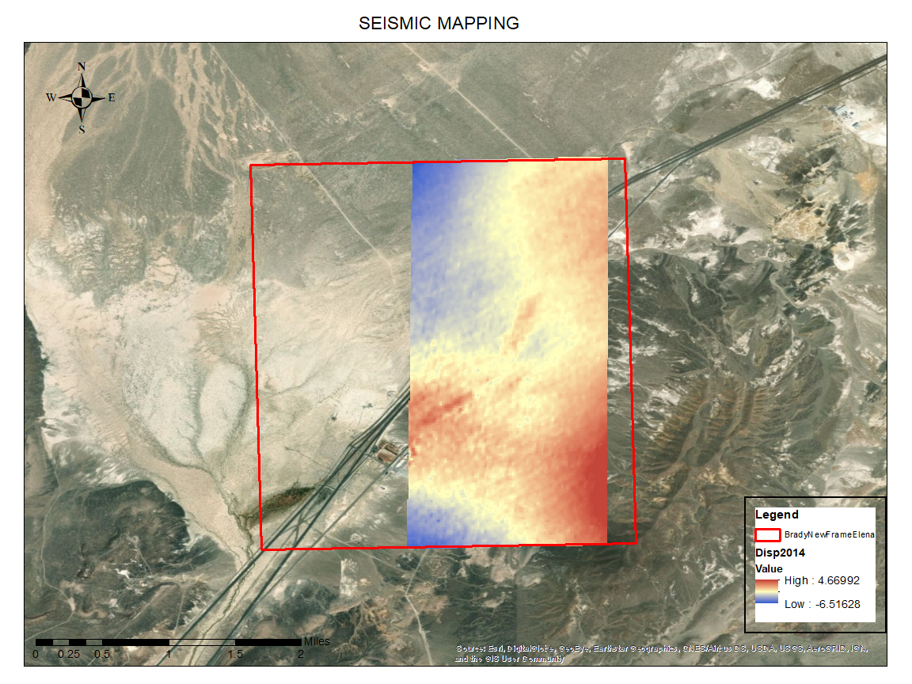

Figure 1. Deformation Analysis by using DinSAR Methodology for 2014 (Ali et al., 2015; Reinisch, Cardiff, & Feigl, 2018).

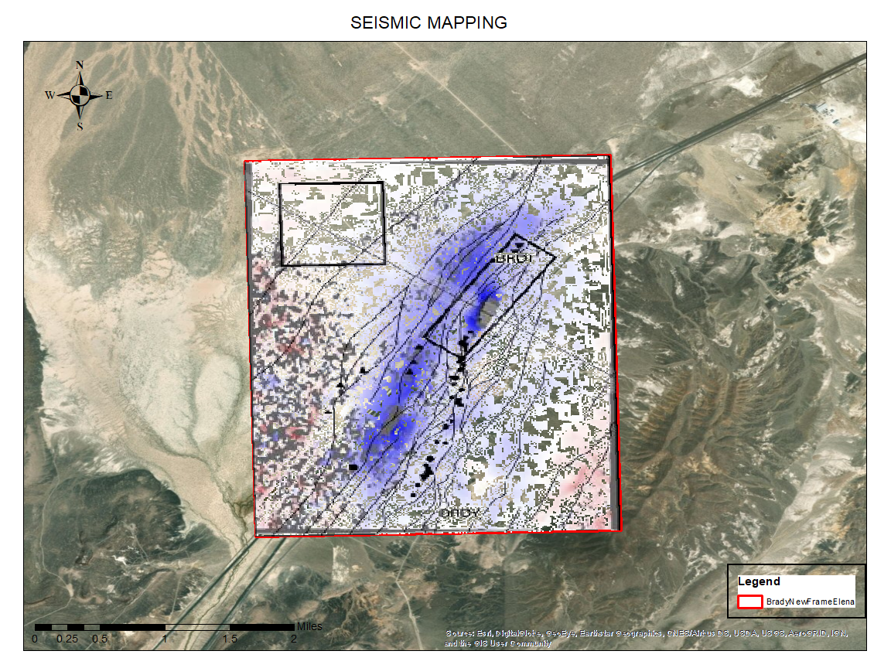

Figure 2. Deformation Analysis between 2016 July 22 and 2017 August 22
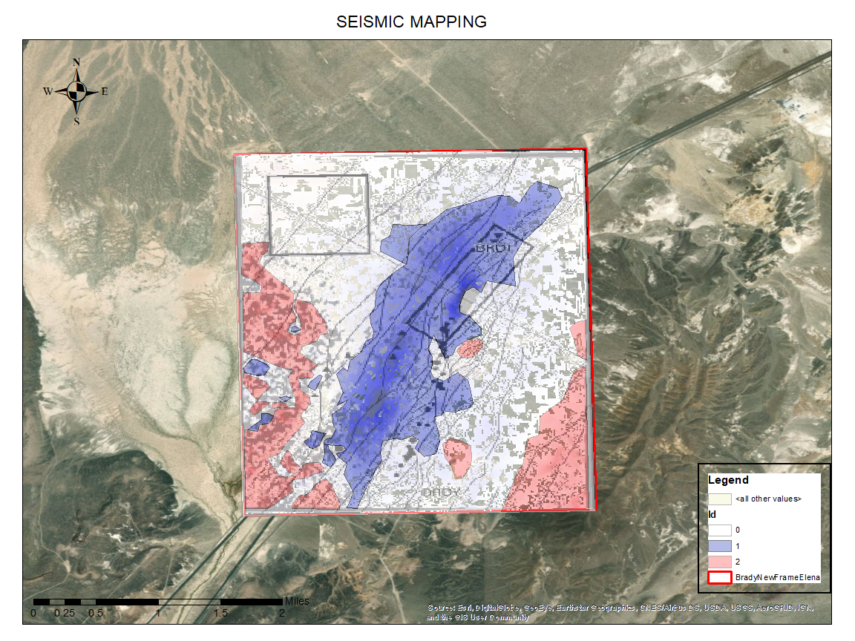

Figure 3. Deformation Analysis between 2016 July 22 and 2017 August 22 and Digitized Vector File.

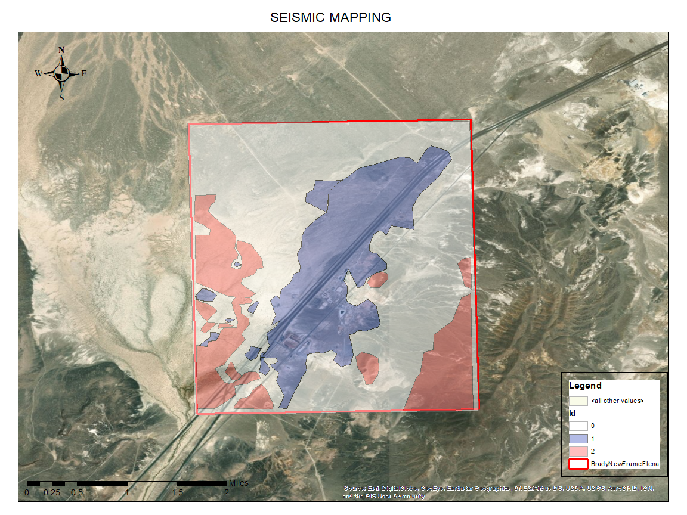

Figure 4. Deformation Analysis between 2016 July 22 and 2017 August 22 Vector File.

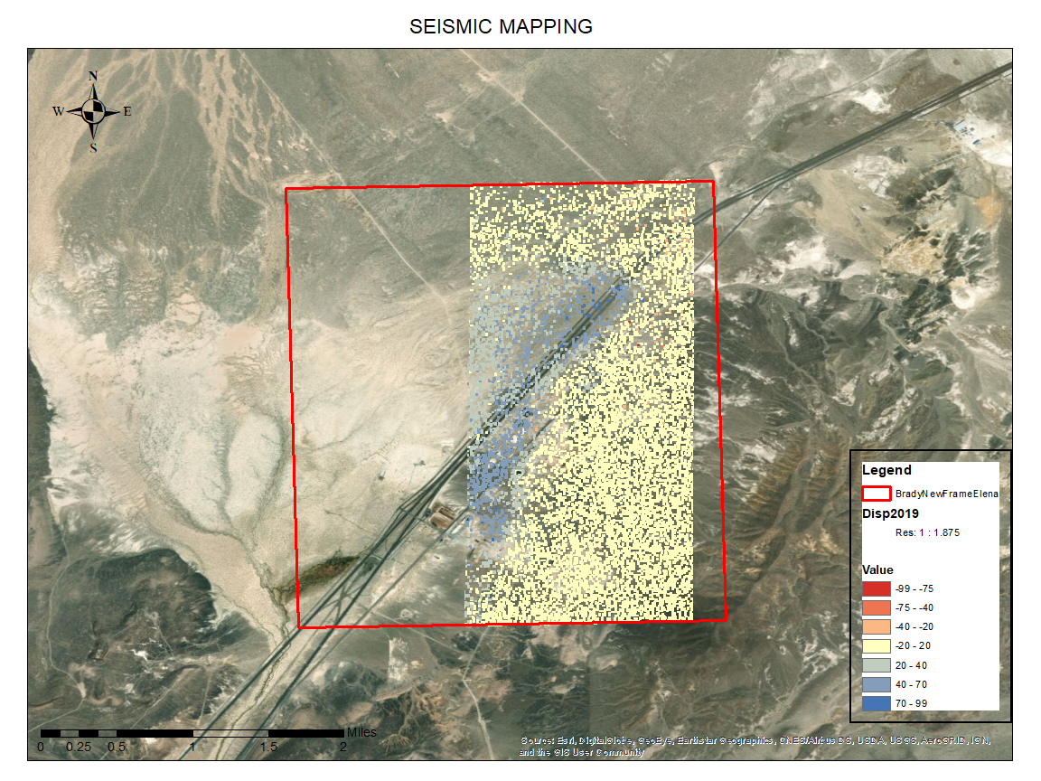

Figure 5. Deformation Analysis 2019.

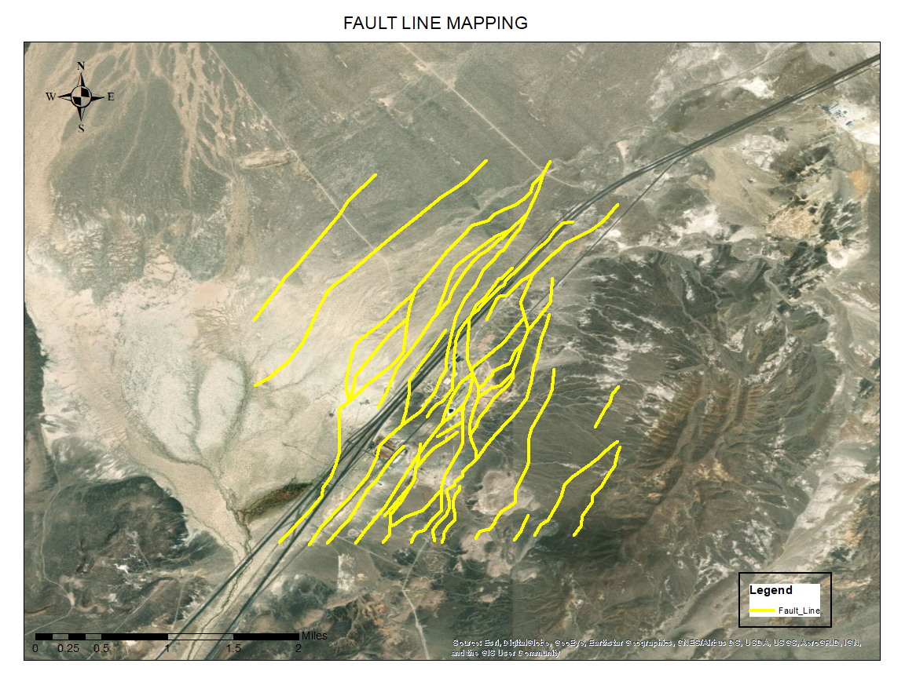

Figure 6. Fault Maps for Bradys.

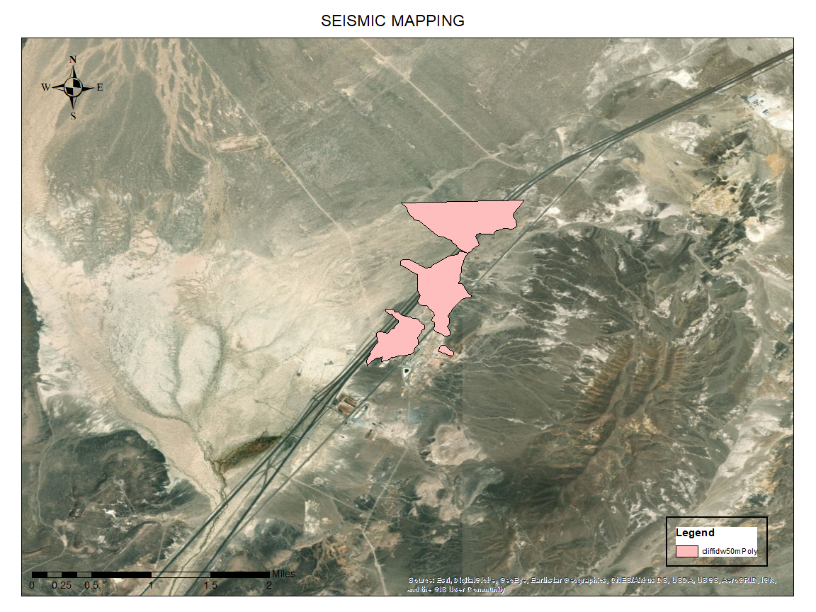

Figure 6. Seismic Vector Maps for Bradys.

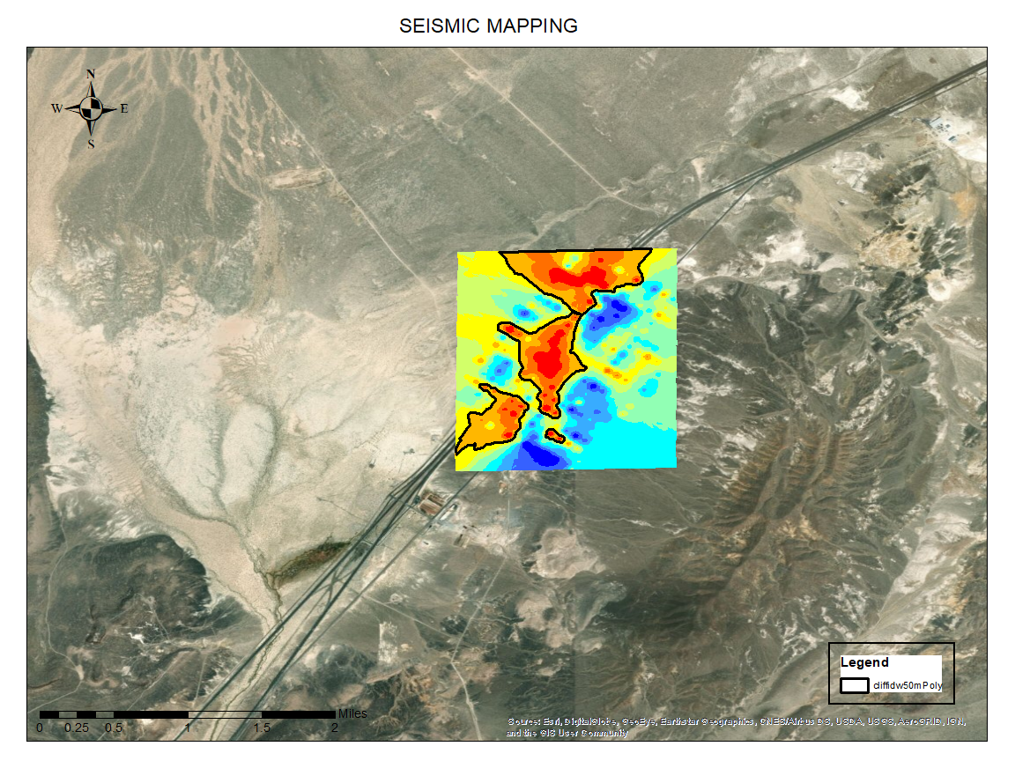

Figure 7. Seismic Raster Maps for Bradys.

REFERENCES
Reinisch, E. C., Cardiff, M., & Feigl, K. L. (2018). Characterizing volumetric strain at Brady Hot Springs, Nevada, USA using geodetic data, numerical models and prior information. Geophysical Journal International, 215(2), 1501–1513. https://doi.org/10.1093/GJI/GGY347

